Ammunition Bunker


While no primary documents explicitly reference an ammunition magazine at Fort Duffield, the fort’s ten 6‑pounder smoothbore cannon positions necessitated a protected storage structure for black powder and artillery rounds. Its presence is therefore inferred from standard U.S. Army engineering practice of the period.
Construction: Timber walls and roof, clay‑sealed seams, baffled ventilation. This earth‑covered, timber‑lined bunker stored Fort Duffield’s black powder and artillery rounds. Following Civil War ordnance regulations, magazines were placed on the safest interior side of a fort, away from flames and moisture. Baffled ventilation protected the powder while keeping the space dry. Fort Duffield’s bunker held 40–50 kegs of powder and hundreds of projectiles for the fort’s guns. We do have reports that cannon balls were still in place as late as 1895.

Ammunition Storage Structure

Fort Duffield, 1861
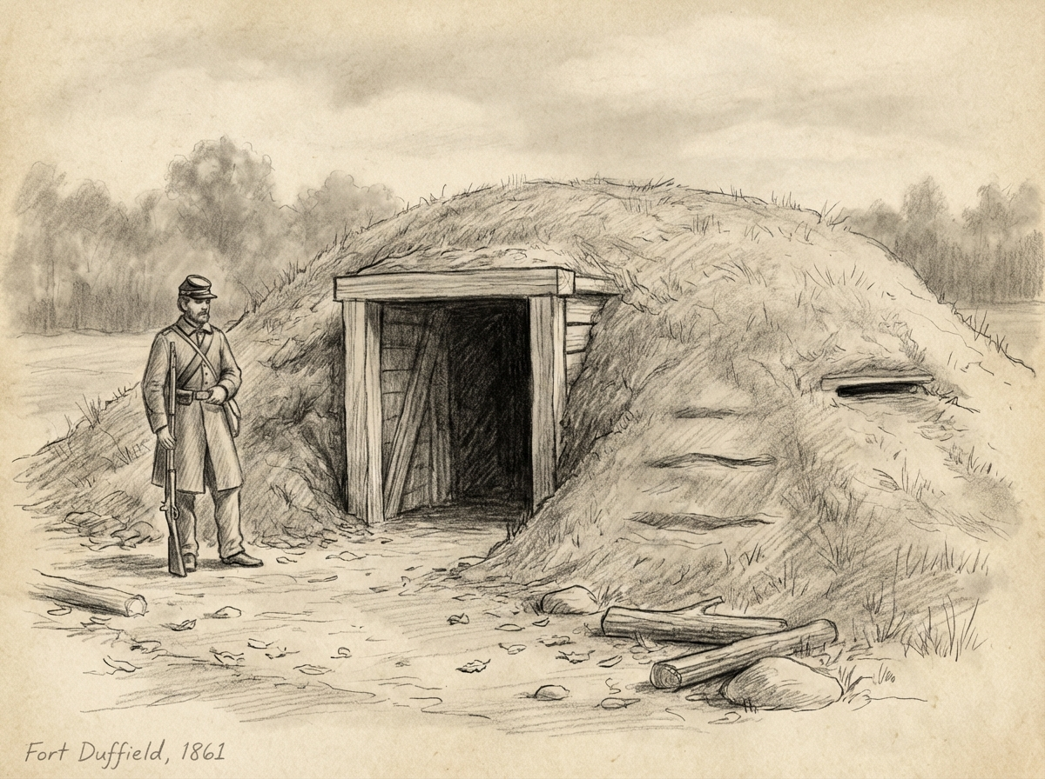
Approximate Dimensions

Length: 25–35 ft
Width: 10–14 ft
Interior Height: 7–8 ft

Earth Cover: 3–6 ft of packed soil

About This Structure

This drawing represents a typical Civil War–era earth‑covered ammunition storage shelter.
Its size and construction reflect the needs of a fortified position on a strategic ridgeline.

Discover More

Scan the QR code on the nearby sign to explore the full history, engineering details, and archaeological context.
Keeping Warm

This is an example of what the Soldiers may have used here at Fort Duffield. Also known as a Crimean oven. This is the most probable version used here.


Albert’s Letter — A Michigan Soldier Writes Home, December 7, 1861”

This letter includes the passage:

“The weather has been cold. Our men have a rather novel way of manufacturing stoves. They dig a trench across their tent floor… cover it with flat stones… and set up a couple of barrels or build a stick chimney.”

“A House in Old Kentuck”
December 12th 1861, Thursday

Cool in the morning but a very pleasant day. Commenced to build us a house. Concluded we might as well settle down in old kentuck as anywhere. Our house is to be 10x 12 ft. About half underground and the other half is composed of boards.

